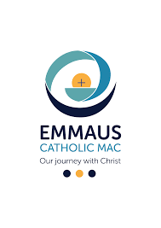
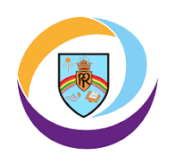
Year 3
Academic Year: 2025-2026

Our Lady Queen of Peace Primary School Class Curriculum Overview

Curriculum Area | Autumn Term 1 |  | Autumn Term 2 |  | Spring Term 1 |  |  |  | Spring Term 2 | Summer Term 1 |  | Summer Term 2
Trip/ Enrichment opportunities | History Man  Workshop |  |  |  | Year 3 Spring Forest School
Religious Education | Our Class Saint – St Teresa of Calcutta
Religious Education | Belonging to God’s Family  (CST – Human Dignity, Common Good)  Prayer  (CST - Human Dignity) | Multi-faith –Hinduism  (CST - Human Dignity, Solidarity)  Advent  (CST – Solidarity) |  |  | Christmas  (CST – Solidarity, Human Dignity  Options for the Poor)  We listen to God’s word at Mass  Reconciliation  (CST – Participation, Human Dignity) |  |  | Lent  (CST - Promoting peace, Option for the poor)  Holy Week  (CST - Human Dignity,  Solidarity) |  | Easter  (CST – Solidarity, Promoting Peace)  Pentecost  (CST –  Common Good) | The Eucharist is a Thanksgiving to God  (CST – Participation, Human Dignity, Common Good)
Writing | I Am A Clever Writer approach used to provide a systematic framework for the development of writing skills; progression documents are available internally and used to ensure high expectations and clear next steps in children's learning.
Reading | ‘The Great Kapok Tree’ by Lynne Cherry  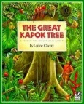  (CST – Stewardship, Options for the poor, Common Good, Solidarity) |  |  | ‘The Stone Age Boy’ by Satoshi Kitamura  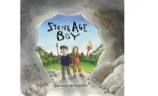  (CST – Human Dignity, Subsidiarity, Solidarity) |  | ‘Meerkat Mail’ by Emily Gravett  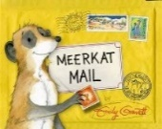  (CST – Solidarity, Option for the Poor) | ‘The Magic Finger’ by Roald Dahl  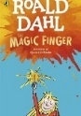  (CST – Stewardship, Option for the poor, Solidarity) |  |  | ‘Arthur and the Golden Rope’ by Joe Todd-Stanton  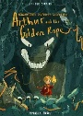  (CST – Human Dignity, Common Good, Solidarity) |  | ‘Tiger Tiger’ by Lynne Reid Banks  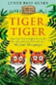  (CST – Stewardship, Solidarity)
Maths | Learning is carefully sequenced according to the White Rose Hub: Progression of Learning guidance, ensuring consistency and progression across year groups.
Maths | Number – Place Value  Number – Addition and Subtraction  Number – Multiplication and Division A |  |  |  | Number – Multiplication and Division B  Number – Fractions A  Number – Length and Perimeter  Measurement - Mass and capacity |  |  |  |  | Number - Fractions B  Geometry - Shape  Measurement –Time  Measurement – Money  Statistics
Science | Light  (Scientist - Ibn-al-Haytham) |  | Forces and magnets  (Scientist - Wiliam Gilbert) |  | Rocks and Soils  (Scientist - Mary Anning)  (CST – Stewardship) |  |  |  | Fossils  (local study)  (CST – Stewardship) | Animals including humans  (Scientist - Jane Goodall)  (CST – Stewardship, Human Dignity) |  | Plants  (Scientist - Mary Seacole)  (CST – Stewardship)
Geography |  |  | Stone Age to Iron Age  Where did early humans settle from the Stone Age to Iron Age and what was it like there?  (CST – Stewardship) |  |  |  |  |  | Feeling hot, hot, hot! (Egypt)  Why is it so hot in Egypt?  (CST – Stewardship) |  |  | Greece  Why do people want to go on holiday to Greece?  (CST – Stewardship)
History | Stone Age to Iron Age  What changes were most significant from the Stone Age to Iron Age?  (CST - Human Dignity,  Solidarity, Common Good) |  |  |  | Egyptians  What were the achievements of the Ancient Egyptians?  (CST - Human Dignity,  Solidarity, Common Good) |  |  |  |  | Ancient Greece  How did the Ancient Greeks impact the Western World?  (CST - Human Dignity,  Solidarity, Common Good)
Music | Charanga Music  Ukelele tuition (10 weeks)  (CST – Participation, Solidarity) |  |  |  | Charanga Music  Three little birds (Reggaae)  (CST – Participation, Subsidiarity, Solidarity) |  |  |  | Charanga Music  Passion Play  (CST – Participation, Human Dignity, Solidarity) | Charanga Music  Bringing us together  (CST – Participation, Subsidiarity, Solidarity) |  | Charanga Music  Reflect/rewind/replay  (CST – Participation, Subsidiarity, Solidarity)
Art | Painting and Mixed Media  Prehistoric painting!  (CST –Solidarity, Human Dignity) |  |  |  | Ancient Egyptians Scrolls  (CST – Solidarity) |  |  |  |  | Drawing  Growing Artists  (CST - Human Dignity, Solidarity)
Design and Technology |  |  | Electrical systems  Electric posters |  |  |  |  |  | Cushions |  |  | Constructing a castle
PE 1 | Get Set 4 PE  Fundamentals |  | Get Set 4 PE  Dance |  | Swimming |  |  |  |  | Get Set 4 PE  Netball |  | Get Set 4 PE  Cricket
PE 2 | Get Set 4 PE  Gymnastics |  | Get Set 4 PE  Fitness |  | Get Set 4 PE  Ball Skills |  |  |  | Get Set 4 PE  Tennis | Get Set 4 PE  Hockey |  | Get Set 4 PE  Athletics
FRENCH  (MFL) | Introductions |  | Numbers |  | Weather |  |  |  | Colours | Home |  | School
COMPUTING | Branching Databases |  | Sequencing sounds |  | Desktop Publishing |  |  |  | Events and actions in programming | Stop frame animation |  | Connecting Computers
PSHE/RSE | LKS2 TEAM (Relationships)  (CST - Human Dignity, Subsidiarity, Options for the poor) |  | LKS2 Think Positive (Health and Wellbeing)  (CST – Human Dignity, Options for the poor) |  | LKS2 Diverse Britain (Living in the Wider World)  (CST - Human Dignity, Solidarity, Common Good, Subsidiarity) |  |  |  | LKS2 Be Yourself (Relationships)  (CST – Human Dignity) | LKS 2 It’s My Body (Health and Wellbeing)  RSE – ‘A Journey in Love’  (CST - Human Dignity) |  | LKS2 Aiming High  (Living in the Wider World)  (CST – Human Dignity, Solidarity)

